Reg.No.: 220701053

**Practical 5**

**Aim:**

Experiments on Packet capture tool: Wireshark Capturing **Packets:**

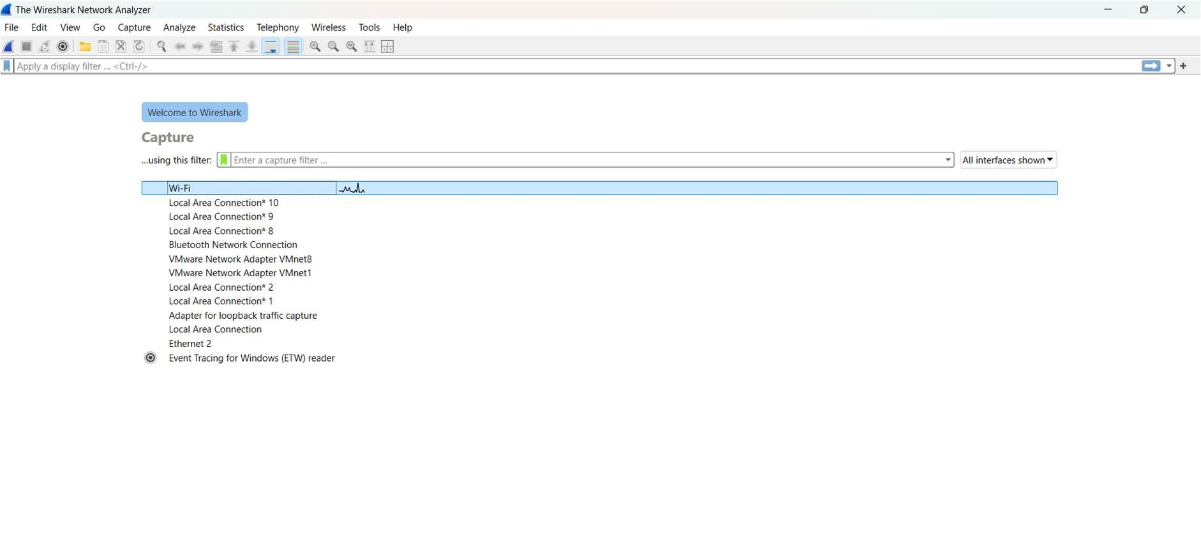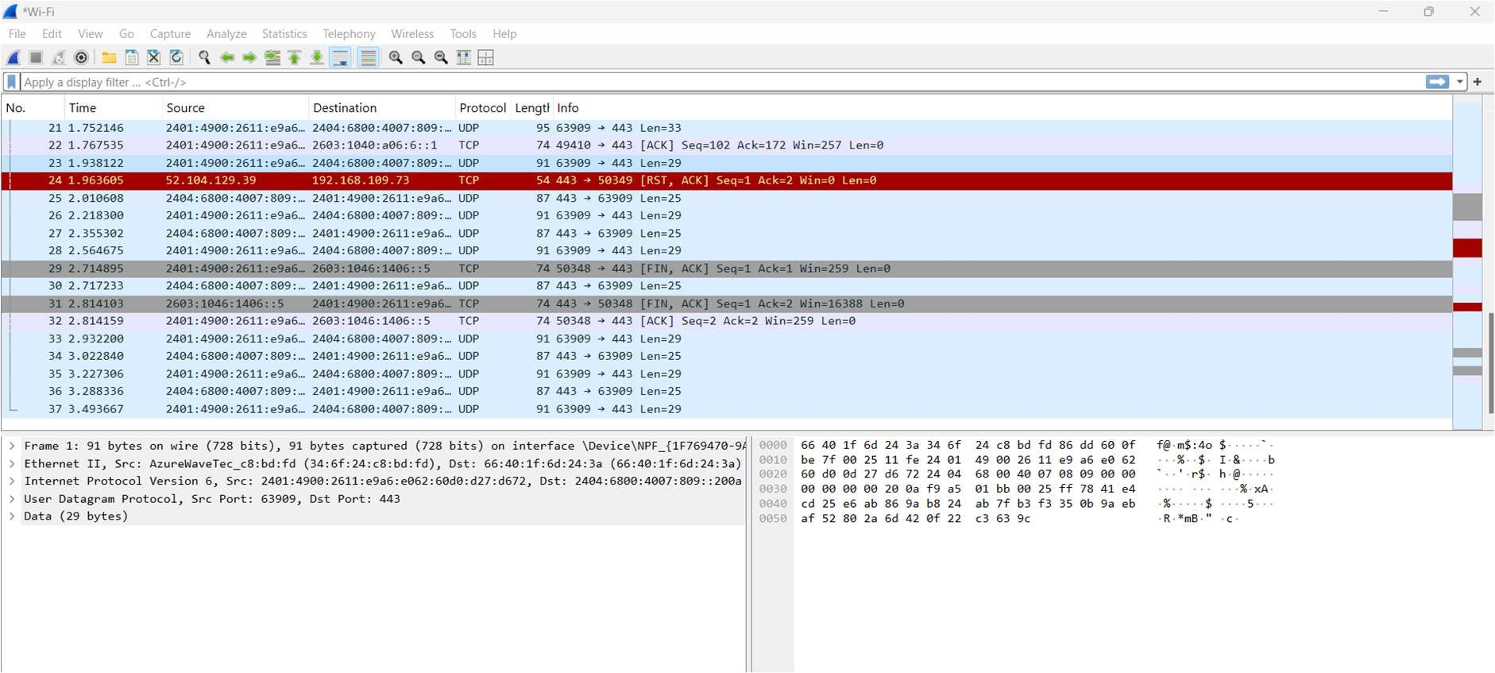

**Color Coding:**

**Filtering Packets:**

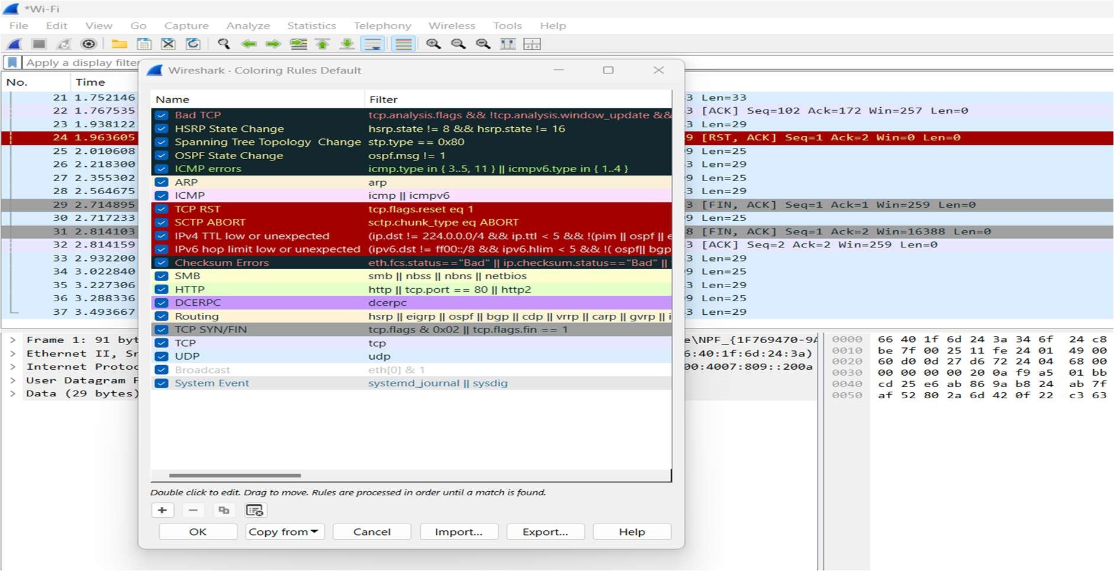

**Display Filters:**

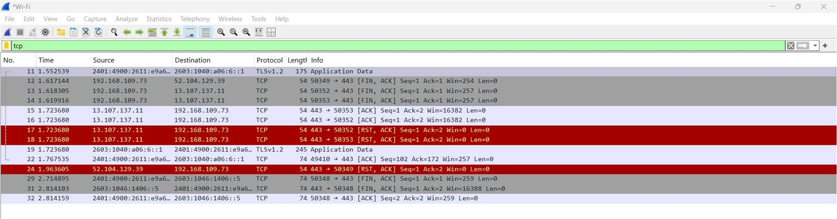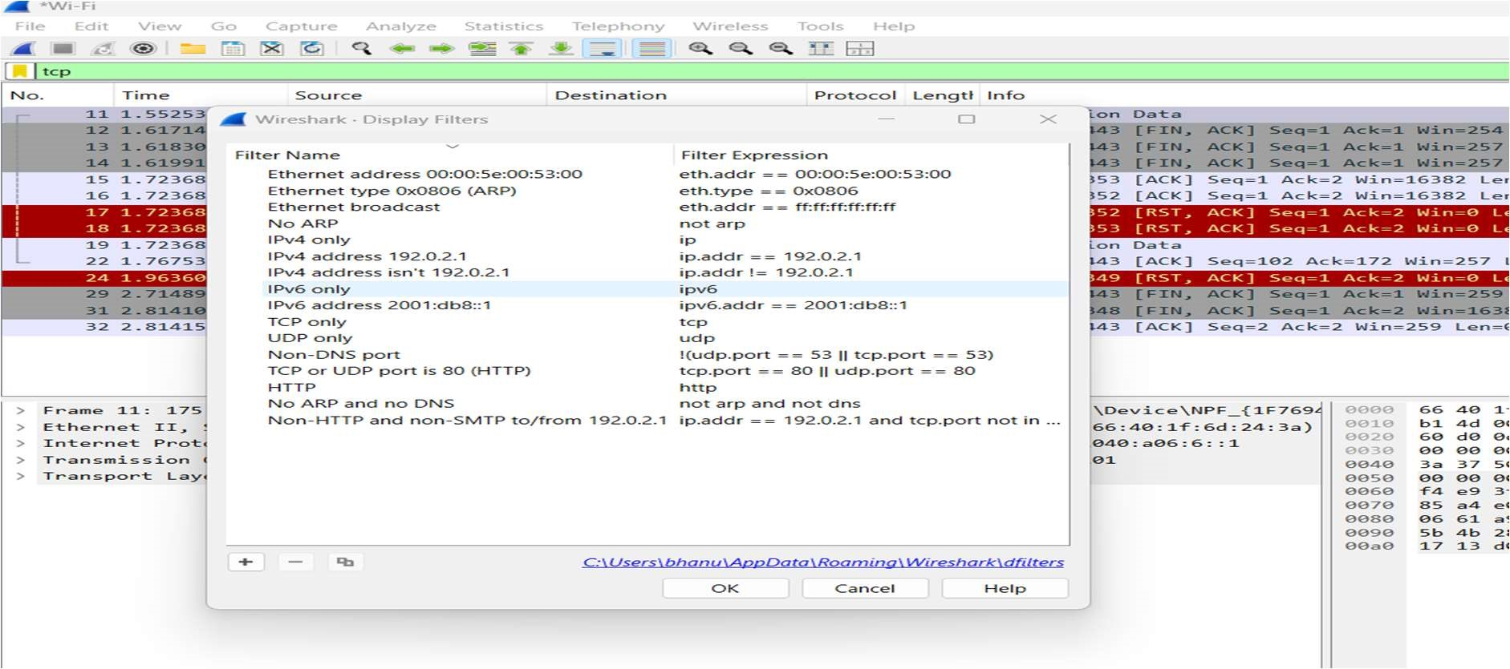

**Tcp Stream:**

**Inspecting Packets:**

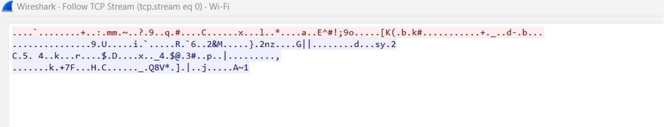

**Flow Graph:**

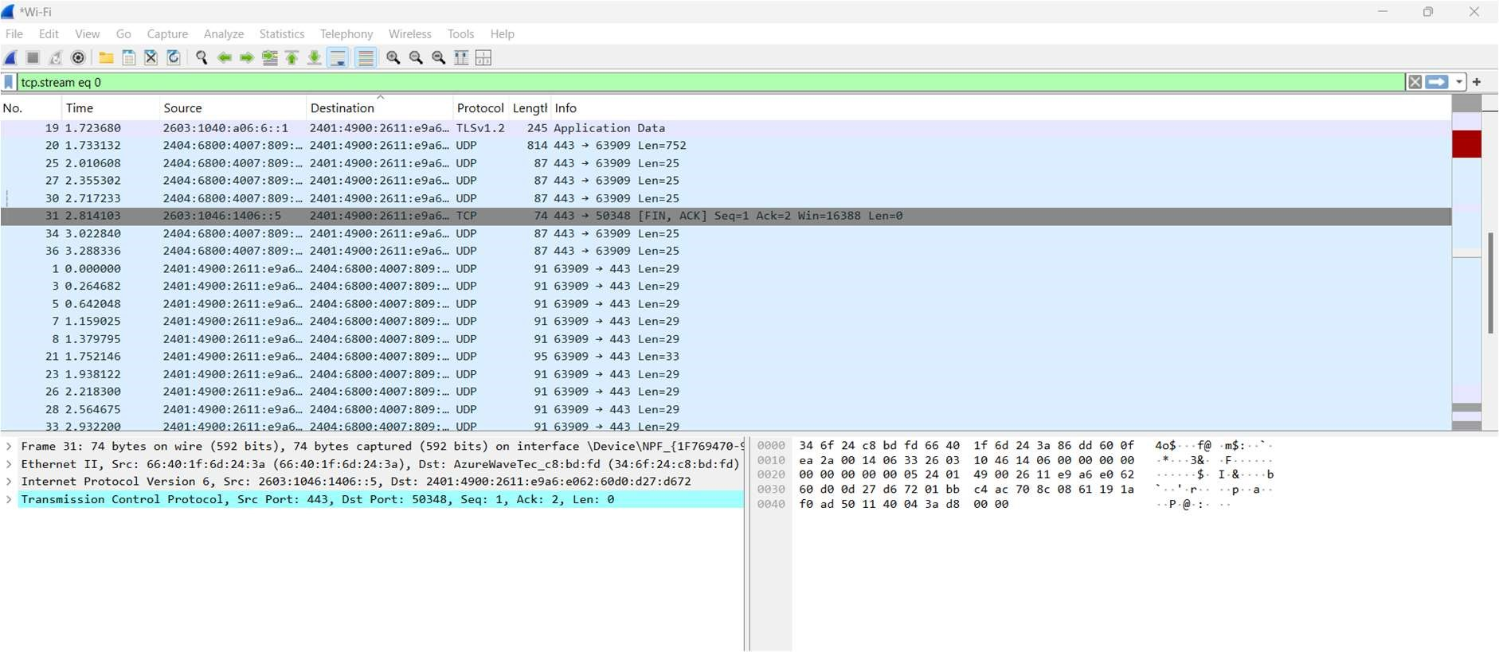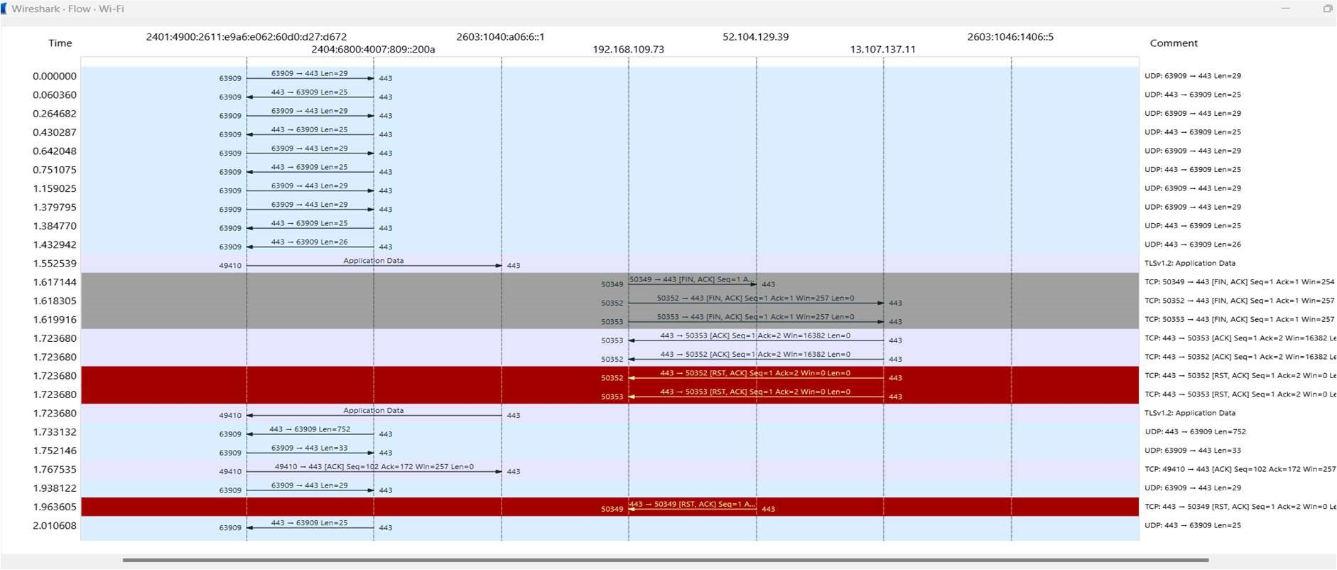

1. **Create a Filter to display only TCP/UDP packets, inspect the packets and provide the flow graph**

**Procedure**

1.Select Local Area Connection in Wireshark.

2.Go to capture →option

3.Select stop capture automatically after 100 packets.

4.Then click Start capture.

5.Search TCP packets in search bar.

6.To see flow graph click Statistics→Flow graph.

Save the packets.

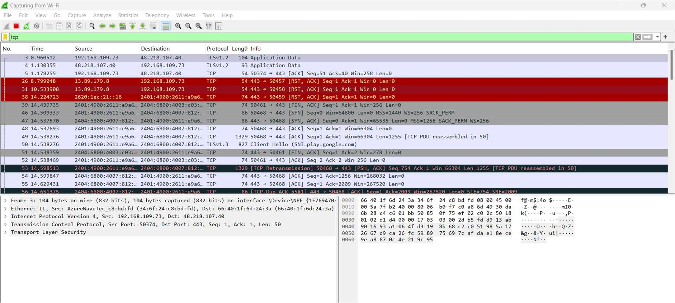

**Flowgraph:**

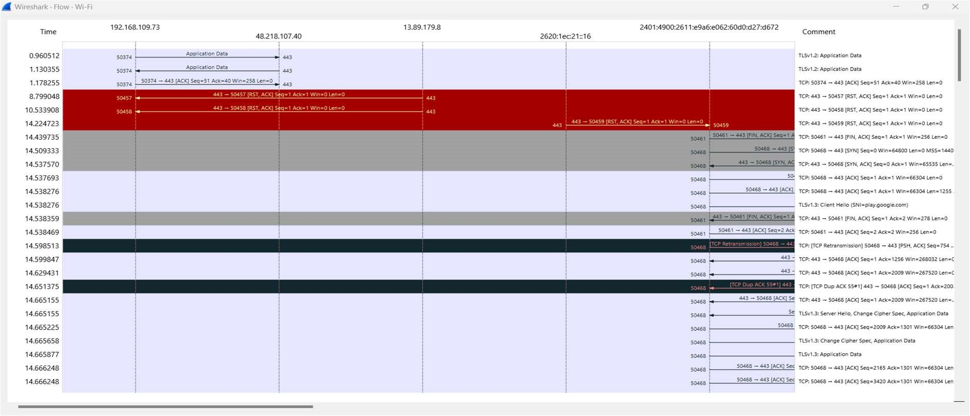

1. **Create a Filter to display only ARP packets and inspect the packets.**

**Procedure**

1.Go to capture →option

2.Select stop capture automatically after 100 packets.

3.Then click Start capture.

4.Search ARP packets in search bar.

Save the packets.

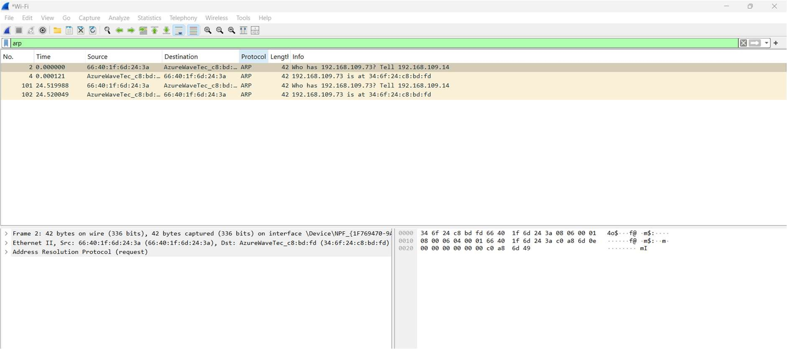

1. **Create a Filter to display only DNS packets and provide the flow graph.**

**Procedure**

1.Go to capture→option

2.Select stop capture automatically after 100 packets.

3.Then click Start capture.

4.Search DNS packets in search bar.

5.To see flow graph click Statistics→Flow graph.

6.Save the packets.

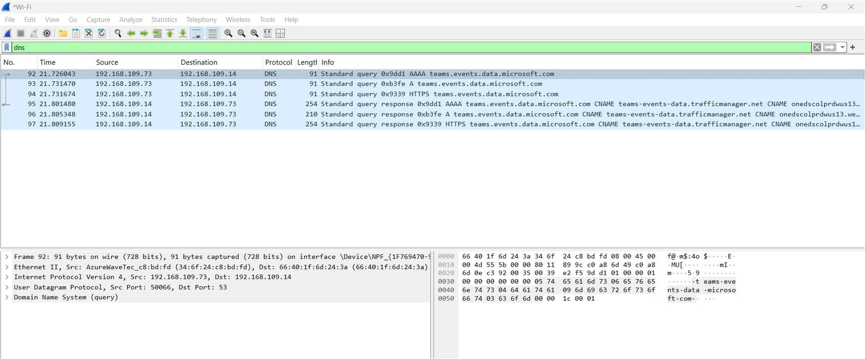

Flowgraph:

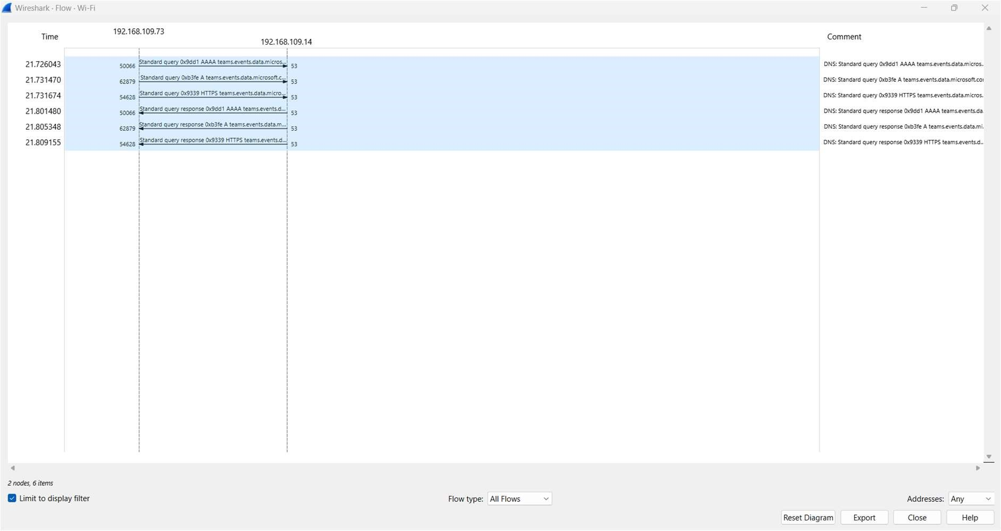

1. **Create a Filter to display only DHCP packets and inspect the packets.**

**Procedure**

1.Select Local Area Connection in Wireshark.

2.Go to capture →option

3.Select stop capture automatically after 100 packets.

4.Then click Start capture.

5.Search DHCP packets in search bar.

6.Save the packets

